STUDENT Joseph Roper

Salford City College | [Company address]

BTEC National 90 Credit Diploma in Creative Media Production

Unit 78: digital graphic for computer games

Contents

Vector Production 2

Vector Presentation 2

Game Case 2

White Mug 3

Black Mug 3

Cartridge 3

Business Card 3

Black Pen 4

White Pen 4

Poster 1 4

Poster 2 5

Black T-Shirt Logo 5

Pixel Production 5

Pixel Presentation 6

Bandit Sword 6

Red Brick – Pattern 1 6

Red Brick – Pattern 2 6

Red Brick – Pattern 3 7

Red Brick – Pattern 4 7

Quartz - Pattern 1 7

Quartz - Pattern 2 7

Quartz - Pattern 3 8

Quartz - Pattern 4 8

Wood – Pattern 1 8

Wood – Pattern 2 8

Wood – Pattern 3 9

Wood – Pattern 4 9

Dirt – Pattern 1 9

Dirt – Pattern 2 9

Dirt – Pattern 3 10

Brick – Pattern 1 10

Brick – Pattern 2 10

Red Dirt – Pattern 1 10

Sand – Pattern 1 11

Scaffolding – Pattern 1 11

Boy Old 11

Boy Young 11

Big City 12

Shanty Town 12

Jail 12

Speech Bubble 12

Tree 13

Witch Hat 13

Enemy 13

Guard 14

Review: 14

L3-U78-DGCG-A3

# Vector Production

Vector Graphics

Vector Graphics is the use of geometrical primitives such as points, lines, curves and shapes or polygons, which are all based on mathematical equations to represent images in computer graphics. Vector images are scalable meaning it retains its quality when zoomed in. They are made of small points named vertexes and paths. A vertex is a certain point within an image that puts a path in the given space. An example of a game that uses vector graphics is the new Mario game Super Mario Odyssey as you can zoom into the character Mario and it will stay the same quality and also as this Mario is 3D. 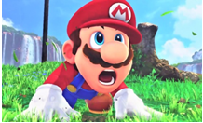

# Vector Presentation

## Game Case

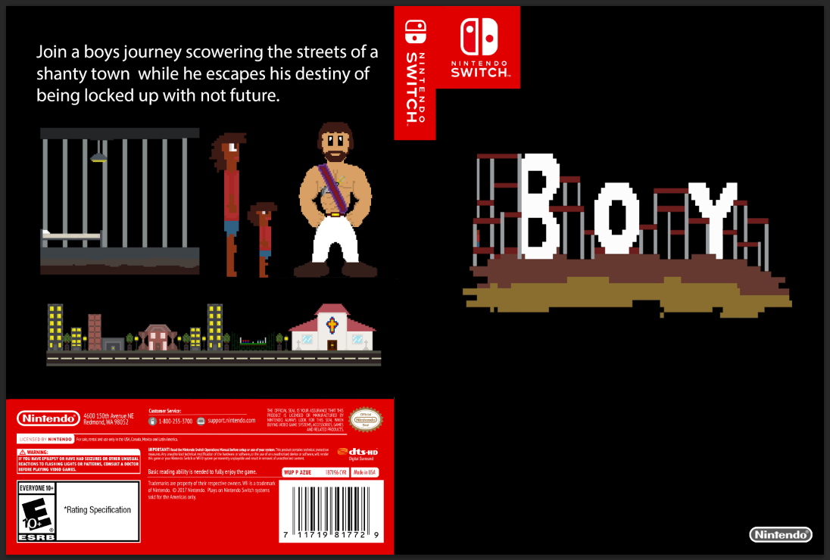

## White Mug

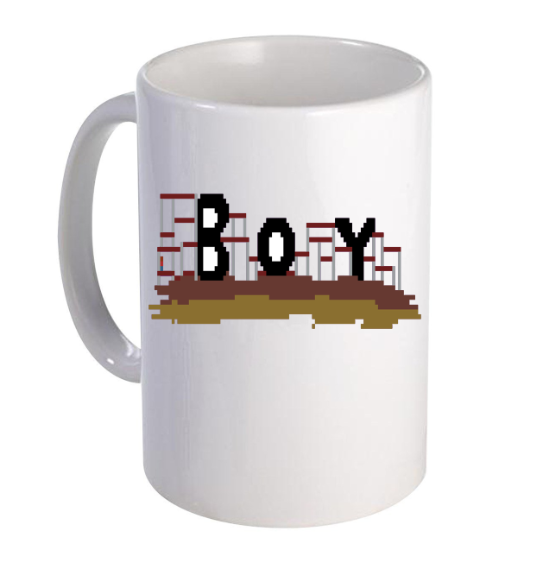

## Black Mug

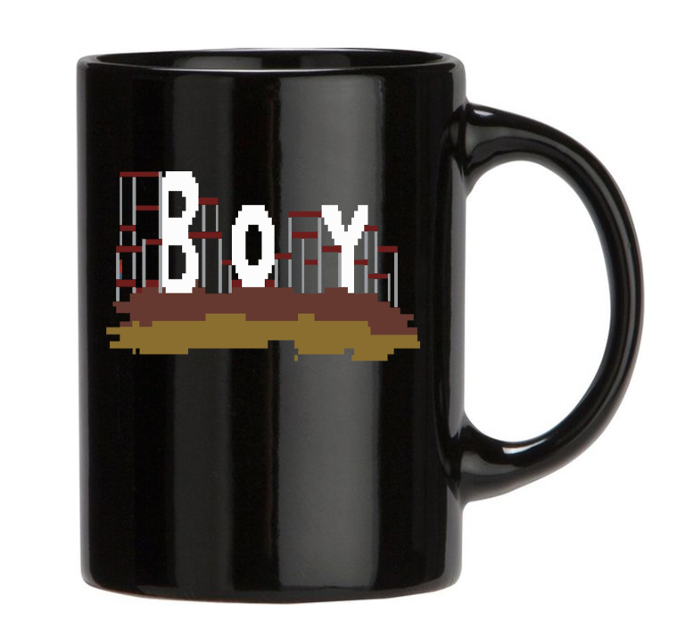

## Cartridge

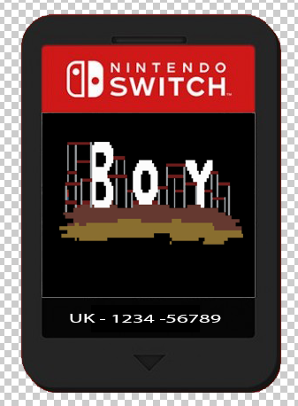

## Business Card

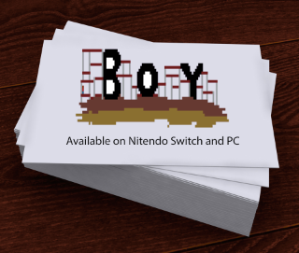

## Black Pen

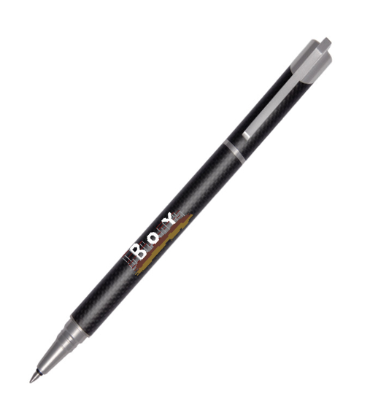

## White Pen

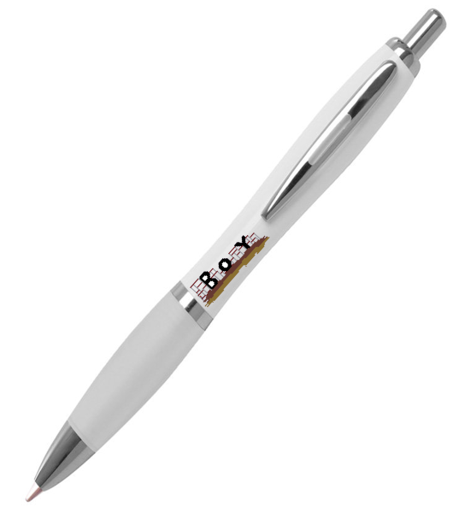

## Poster 1

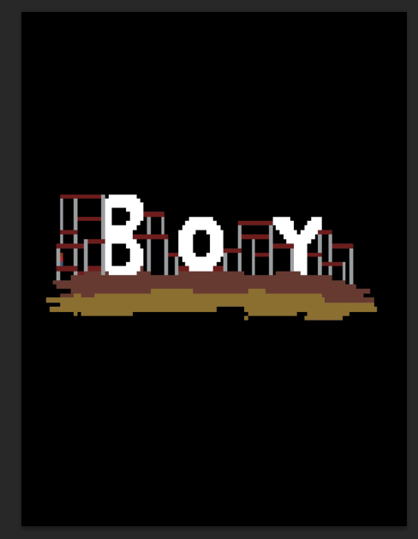

## Poster 2

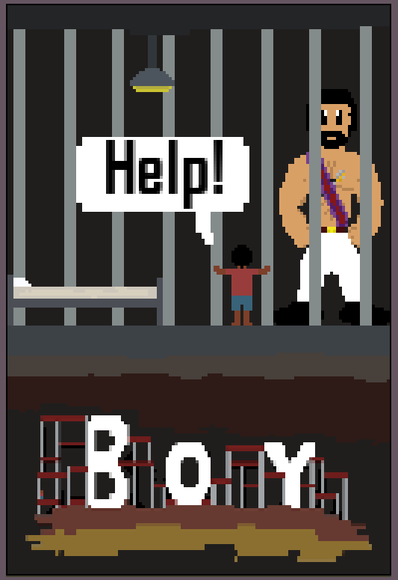

## Black T-Shirt Logo

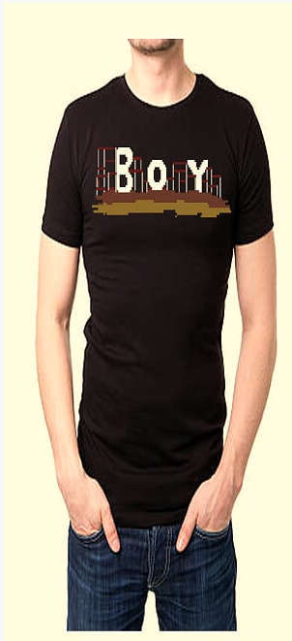

# Pixel Production

Pixel Art

A form of digital art where images are edited on the pixel level. This type of graphics is mainly used in most old and/or relatively limited computer and video games. Most mobile phone games are pixel art type games. Pixel art is created in a raster based graphic such as MS Paint or Adobe Photoshop and uses bitmaps. An example of a game that uses pixel art is Undertale which uses raster based graphics as if you zoom in on one of the characters the image will lose quality. 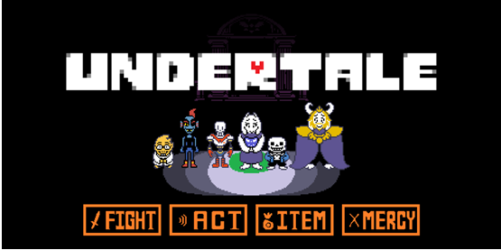

# Pixel Presentation

## Bandit Sword

This is my “Bandit” sword this will primarily be the guards weapon in the game although I will include a segment in my game allowing the player to use this item to solve a puzzle when they must try and break out of a holding cell.

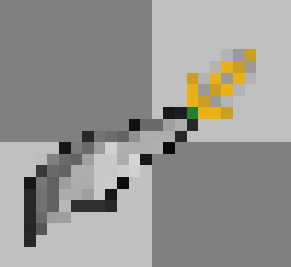

Red Brick – Pattern 1

I will use this to make buildings in my game.

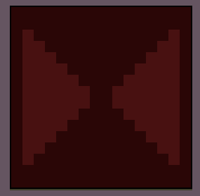

Red Brick – Pattern 2

I will use this to make buildings in my game.

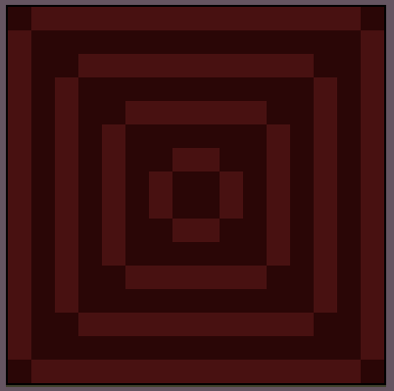

Red Brick – Pattern 3

I will use this to make buildings in my game.

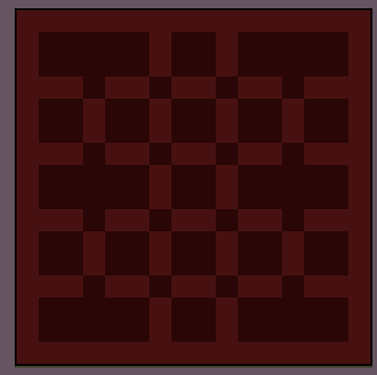

Red Brick – Pattern 4

I will use this to make buildings in my game.

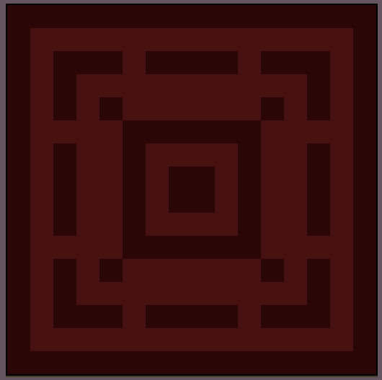

Quartz - Pattern 1

I will use this to make buildings in my game. Such as the church in the big city.

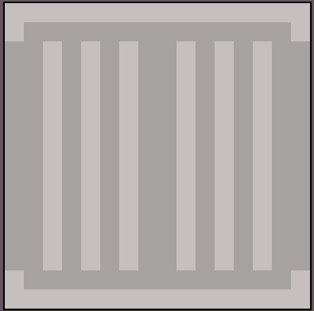

Quartz - Pattern 2

I will use this to make buildings in my game. Such as the church in the big city.

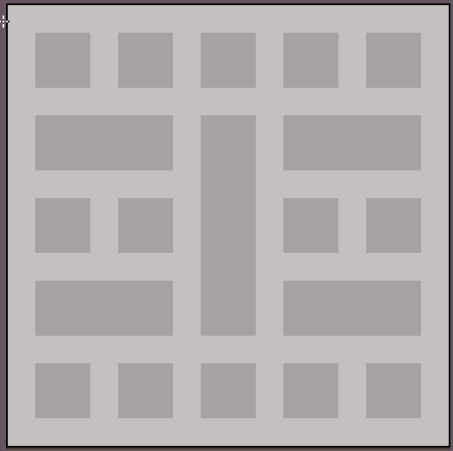

Quartz - Pattern 3

I will use this to make buildings in my game. Such as the church in the big city.

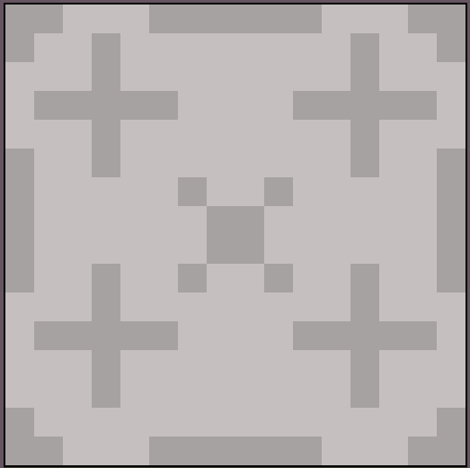

Quartz - Pattern 4

I will use this to make buildings in my game. Such as the church in the big city.

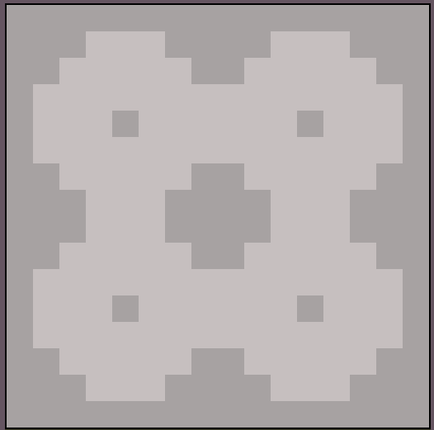

Wood – Pattern 1

I will use this to make buildings in my game.

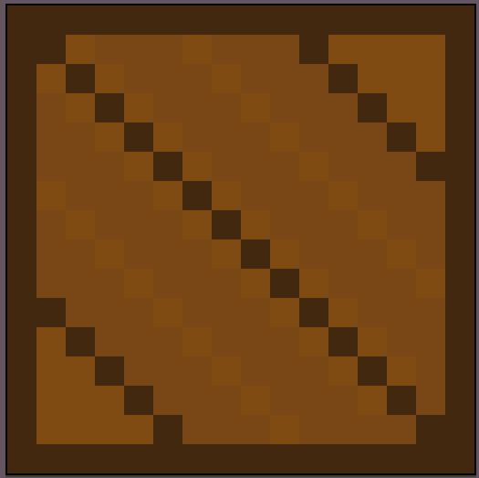

Wood – Pattern 2

I will use this to make buildings in my game.

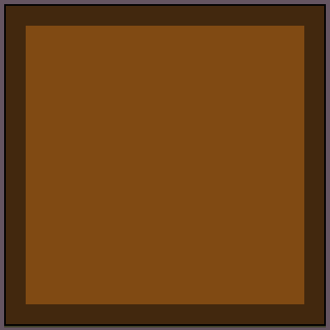

Wood – Pattern 3

I will use this to make buildings in my game.

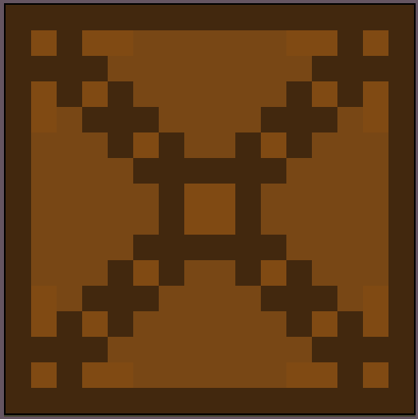

Wood – Pattern 4

I will use this to make buildings in my game.

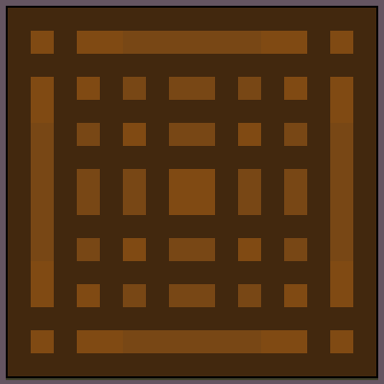

Dirt – Pattern 1

I will use this to make the floor in my game.

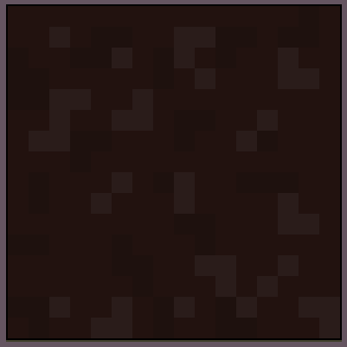

Dirt – Pattern 2

I will use this to make the floor in my game.

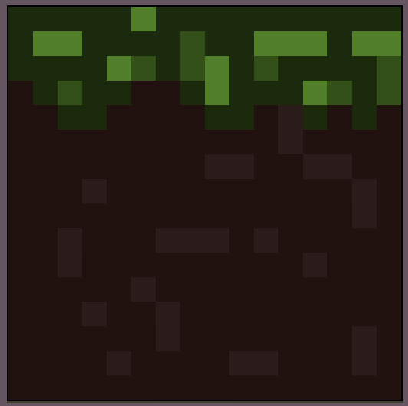

Dirt – Pattern 3

I will use this to make the floor in my game.

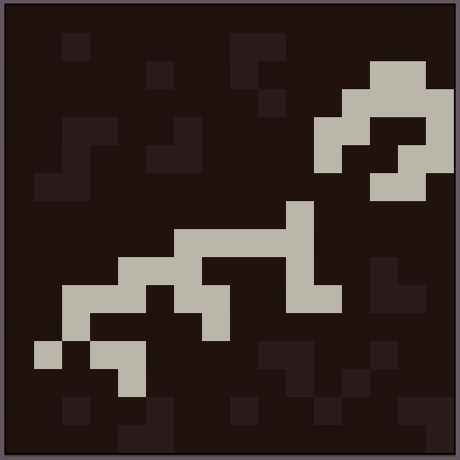

Brick – Pattern 1

I will use this to make buildings in my game.

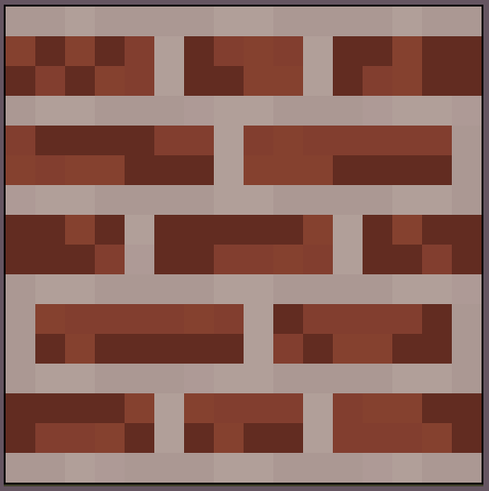

Brick – Pattern 2

I will use this to make buildings in my game.

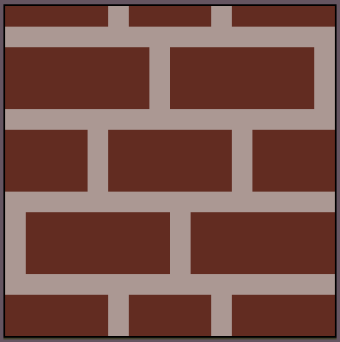

Red Dirt – Pattern 1

I will use this to make the floor in my game.

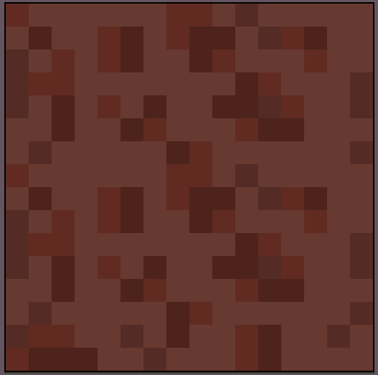

Sand – Pattern 1

I will use this to make the floor in my game.

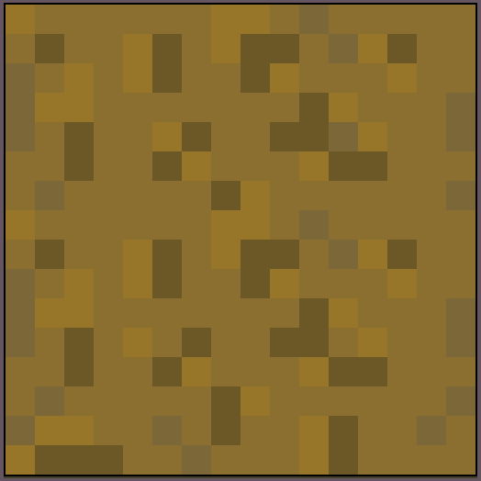

Scaffolding – Pattern 1

I will use this to make buildings in my game.

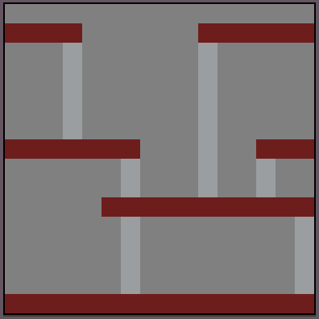

Boy Old

This is the main/playable character in my game, this is the older version of the character. The player will grow up half way or to the end of the game as he has spent so long almost half of his life avoiding the police.

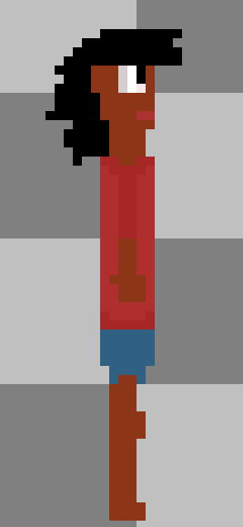

Boy Young

This is the young version of the main/playable character you start the game in this form as you see him steal from the shop keeper ad begin his life of misshapen crime.

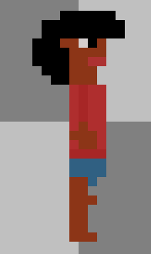

Big City

This is the last map the player will venture, when he finally meets up with his lost parents.

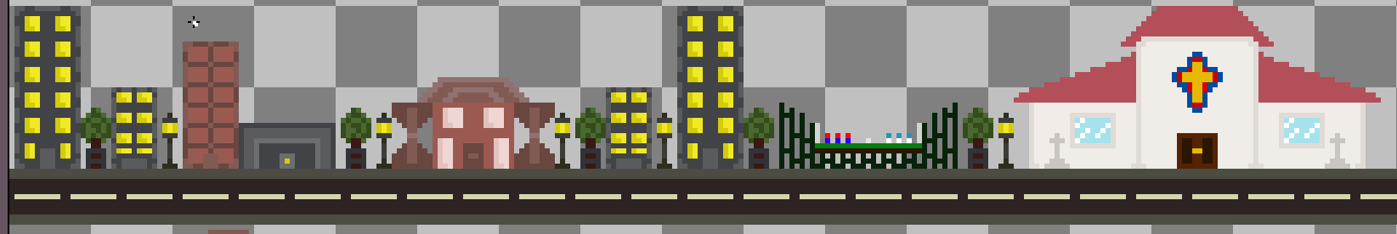

Shanty Town

This will be a backdrop for the first map where the player starts the game.

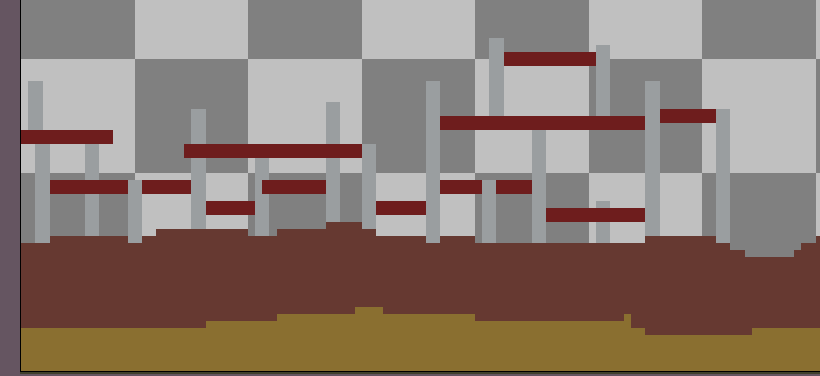

Jail

This is the holding cell where the player is placed so that the guard can call his parents, but the player doesn’t know this, so they try to escape.

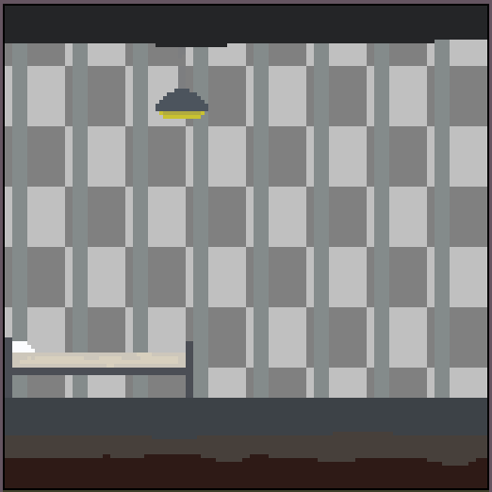

Speech Bubble

This will be used in my game to display text and can be reused for other games/projects I start.

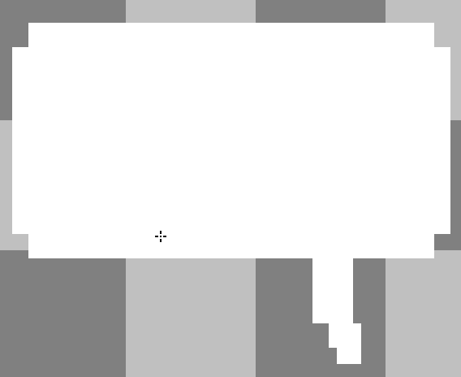

Tree

This will be used in the background of the Big City map in the park which contains trees. I can also reuse this for future projects.

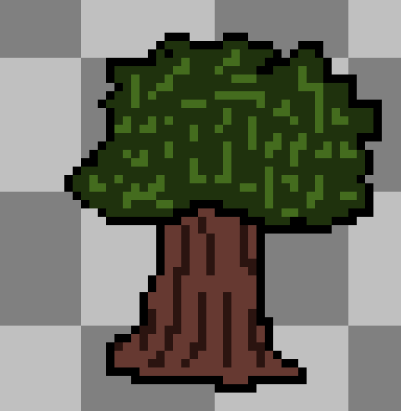

Witch Hat

This will be worn by an NPC which cooks the user items to restore the players health. This will also be an unlockable for the player to wear which the player can buy from the clothes store in the big city.



Enemy

This will be an enemy in the game which will only be able to do small amounts of damage because as you can see from the image the enemy is scrawny.

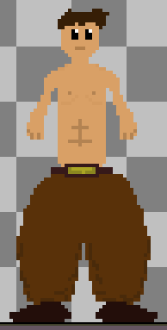

Guard

This is the main boss of the game as the is the head of the guard friends of the parents trying to get the lost boy back to his parents.

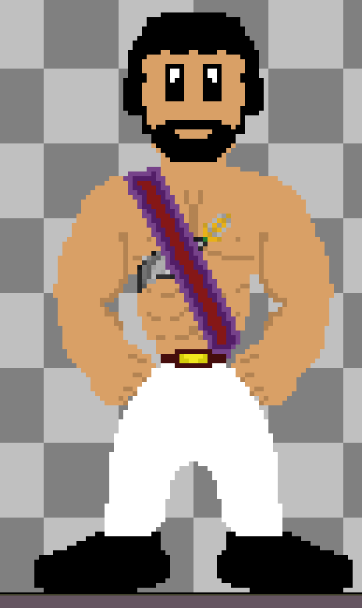

# Review:

Firstly, for assignment 1 I was asked to write multiple reports on the subject graphics covering the different styles of graphics/art such as: anime, expressionism and various other art styles. Then I had to inform the reader of various gaming terminologies such as sprites, vehicle and environments. Secondly, for assignment 2 I was asked to produce a mood board and story board of my game idea as well as covering research on legal and ethical consideration when making a game such as: religion, females in video games and copyright issues. Finally, for this task assignment 3 I have been asked to create a bunch of assets for my game while also designing promotional material for example, posters and t- shirts.

My intended output for my digital graphics are to use them in a video game I will develop as well promotional material for that game. For example, I will use the logo I created for promotional material to advertise my game to get buyers/players.

I can also repurpose my assets for future games as almost all my assets can be reused except for the logo for obvious reasons. I can even put the main character “Boy” in future games as a background character.

Since my game is about is about a small African child and his journey through a shanty town based on the slums of Johannesburg I would have to consider how I would display ethnicity in my game as even if I get the skin tone slightly off it could start an outrage upsetting many people or if certain racial slang is used in the game the same effect will be caused.

Yes, I used a scanner on my phone to transport my concept art onto the computer, so I could put it in my work. I used this to make up my storyboard.

|  |  |
| --- | --- |
| Scene 1 | Scene 2 |
|  |  |
| Description: A young boy (the player) wakes up from sleeping on the dirty street floor. | Description: He walks around (while he player enjoys the scenery/view) and his stomach starts to rumble. |
| Scene 3 | Scene 4 |
|  |  |
| Description: The boy finds a stall selling bread but realises he has no money to pay, but his stomach continues to growl and roar. | Description: He decides to grab the bread and run but as he lays his finger on the bread the shopkeeper grabs his arm and says “Boy! Do you know what we do to thieves!” as he proceeds to pull out a big butcher’s knife. |
| Scene 5 | Scene 6 |
|  |  |
| Description: Suddenly a guard shouts stop and walks to the shopkeeper saying “can’t we be civilised? And lock him up?” | Description: The guard grabs you and throws you in a cell. Then the game starts as you must escape the cell and run away from home to the big city. |

I could have used a scanner on a printer, although I didn’t as it was easier to use my phone instead because it is portable has storage on the device and I could also upload the scanned item onto my OneDrive (an online storage program).

Aseprite is a software used for making pixel art and it is where I made most of my assets for this work. It has keyboard and some mouse shortcuts for every tool.

“B” is the “Pencil” tool it is used for drawing/ placing coloured pixels.

“G” is the “Paint Bucket” tool it is used to fill certain areas with colour completely.

“I” is the “Eyedropper” tool once pressed you left or right click the mouse on a colour to turn your “Pencil” tool into that colour.

“E” is the “Eraser” tool it is used to delete coloured pixels you have placed.

“M” is the “Marquee” tool once pressed you can click and drag a rectangle over your work, when the mouse is clicked after this you can decrease or increase the work in the rectangle, move it around, copy it, paste it and delete it.

“Mouse Wheel” is the “Move” tool once pressed you can move around your canvas.

Symmetry Tool under View in the top left of the program this is an option once pressed a line will show going through the canvas and everything drawn on one side of the line will show on the other.

Every tool I used in Aseprite I also used in Photoshop they just had different shortcuts.

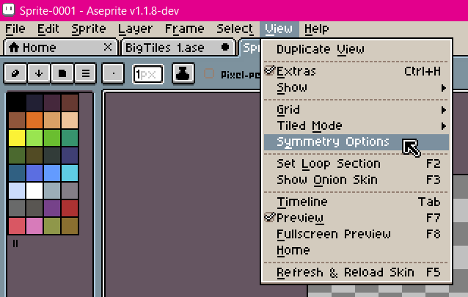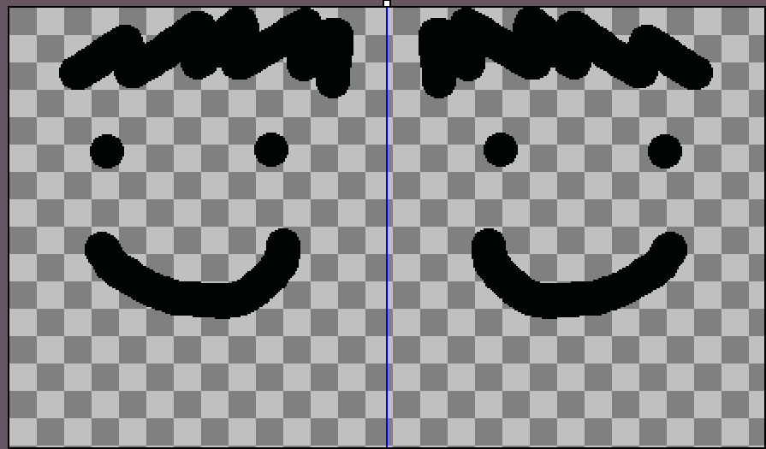

Photoshop is a program intended to edit digital graphics and it is used mainly for that purpose, creating and manipulating photos/images. In this assignment I have used Photoshop for one of its main purposes to manipulate images for example with my games case I moved images from other programs by manipulating them (changing the images size). 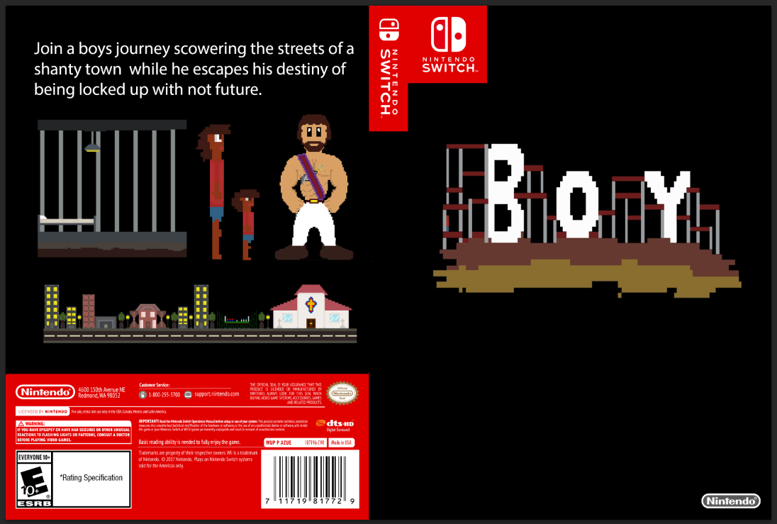

I had four copies of all my digital graphics in four different places. The first place where I store my digital graphics is on my USB drive which I always have on my person. The second and third place is on my student OneDrive and my personal OneDrive. The final place I store them is in a document which I can access only on my college computers. I have four copies of everything acting as backups of one another, so I will always have access to my assets to work on and in case I lose a file I will always have a recent backup.

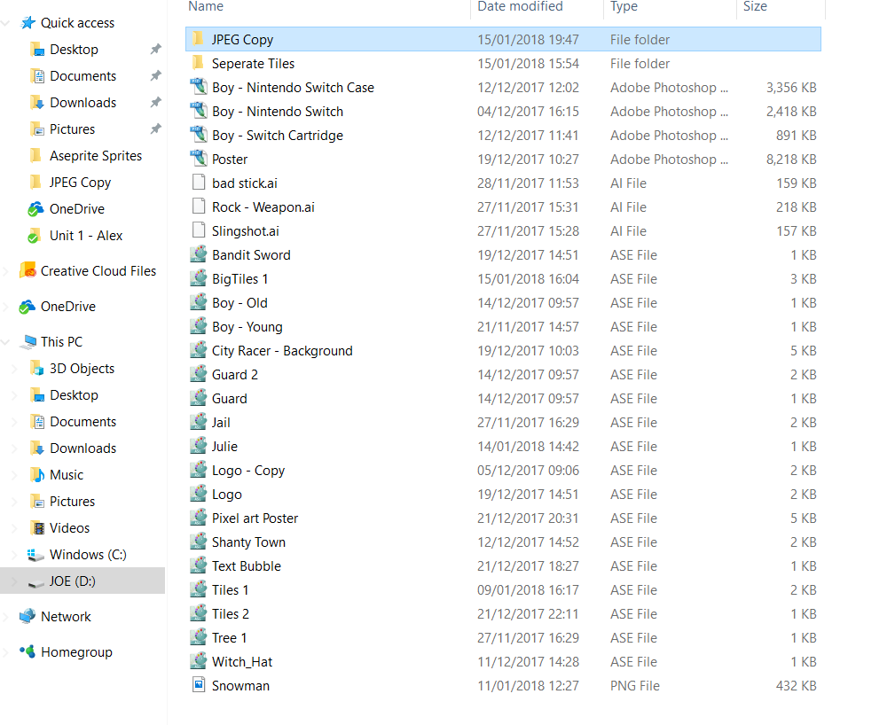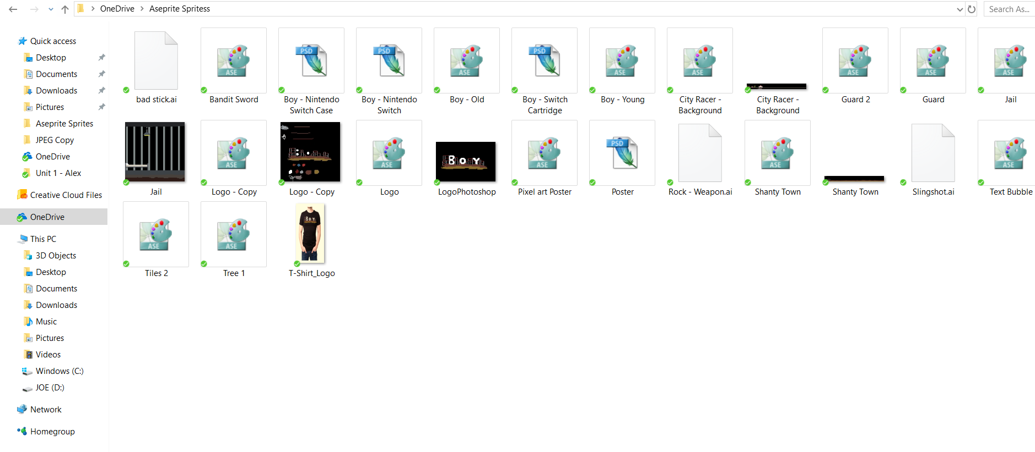

The program I used to make pixel art saves the work as ASE type files which is raster and Photoshop only accepts JPEG file types, so I had to convert my work from ASE to JPEG to edit my work on Photoshop.

Yes, I believe I did my work to the best of my ability due to my lack of artistic ability. As I have fulfilled all the assets I was required to make plus many more.

There are many technical aspects of the assets I have made for example for all the promotional material made on Photoshop uses layers in each of them. Layers basically act as see through paper so on layer 1 can have black background, then on layer 2 I would have my Nintendo Switch game case template, then on the third layer I have my logo and so on. With Photoshop I can make layers invisible this is a good feature which I use to see which layer is which and when working sometimes on one layer I will make the others invisible, so I can focus on that specific layer.

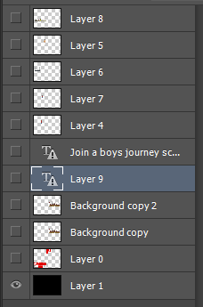 

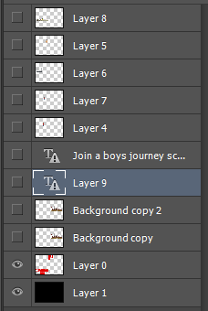 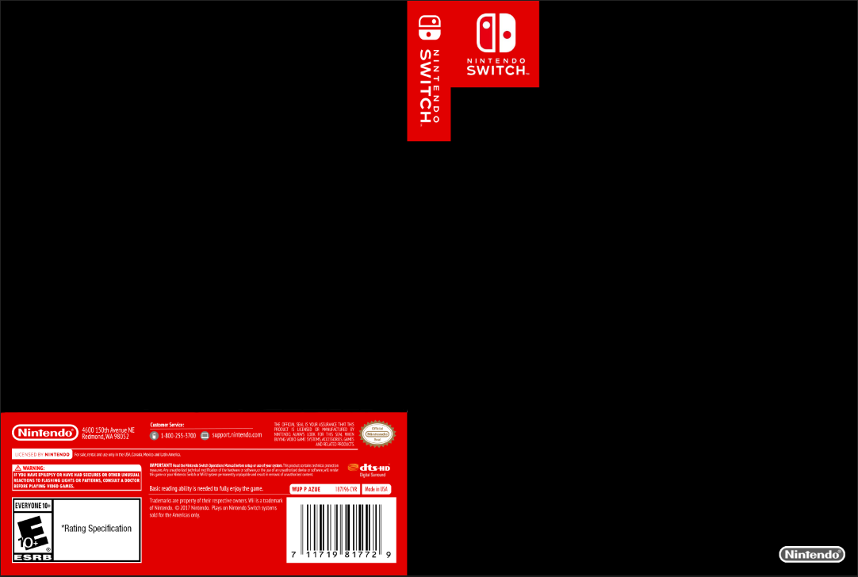

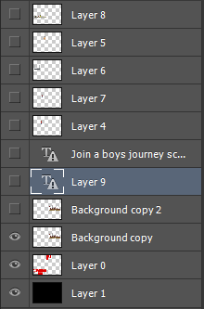 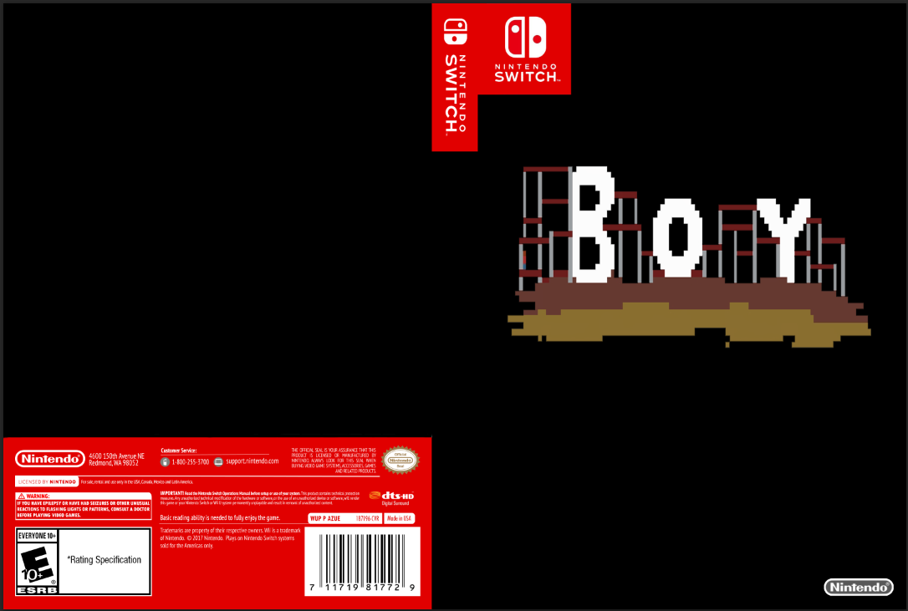

When making the assets for my game for example my logo I made sure to use contrasting colours for example I have two versions of my logo one for when I want to put it on a black background and one for a white background. The one for the white background has black letters so it pops out to the eye it’s the same for the black background the logo letters are coloured white, so it pops out.

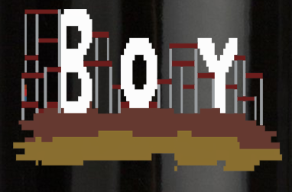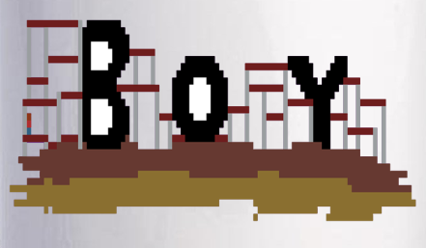

I preferred making the first part of the assignment when I made my character and logo as I was able to use my imagination and it didn’t really matter if I made a lot of mistakes as I could go over and refine my work later. However, I didn’t like that I had to make weapon sprites for my game as the game I had in mind wouldn’t have weapons, so I had to make some weapon sprites for my game which I had no intention of including in my game.

If I had more time on this project I would continue to work on assets for the game making the maps I have created bigger and more detailed. I would also start creating the game most likely in Construct 2 and write up a clear story and run it over with classmates to see if they like it.

I have learned how to use Photoshop, Aseprite and Adobe Illustrator on a more in-depth level as I can make assets for video games to a suitable level without having an adequate artistic ability. I have also learned what is needed for a good promotional package for video games such as posters and t-shirts.

I would start with a plan on which assets I should start with and add a deadline, so I will not waste time procrastinating about certain things that don’t particularly matter such as between the colour light green and dark green for grass in a game. I would also only use programs I am familiar with, so I don’t waste time barely learning how to use a new program like I did with this assignment I tried to learn how to use Adobe Illustrator when I should have stuck with using Photoshop and Aseprite.

To see if people would like my assets I placed all of them into a Power Point Presentation for two of my peers to comment on. The response was mostly positive with some of the assets getting constructive criticism. I will include the presentation along with my work.